**Car Collection App - Python Web Basics Exam**

*The app allows the user to browse different cars, including their price, category, year, type, and model. The user can create, edit, or delete cars at any time. He/ She can also edit or delete his/ her profile.*

## 1. Skeleton

You are provided with all the needed **HTML pages**, **images,** and **CSS** for the project.

## 2. Database

You will need **2 models**:

* **Profile**
  + **Username**
    - Character field, **required**.
    - It should consist of a **maximum of 10 characters**.
    - It should consist of a **minimum of 2 characters.** Otherwise, raise a **ValidationError** with the message: **"The username must be a minimum of 2 chars"**
  + **Email**
    - Email field, **required**.
  + **Age**
    - Integer field, **required**.
    - The age **cannot be below 18**.
  + **Password**
    - Character (password) field, **required**.
    - It should consist of a **maximum of 30 characters**.
  + **First** **Name**
    - Character field, **optional**.
    - It should consist of a **maximum of 30 characters**.
  + **Last** **Name**
    - Character field, **optional**.
    - It should consist of a **maximum of 30 characters**.
  + **Profile** **Picture**
    - URL field, **optional**.
* **Car**
  + **Type**
    - Character (choice) field, **required**.
    - It should consist of a **maximum of 10 characters**.
    - The choices are **"Sports Car"**, **"Pickup"**, **"Crossover"**, **"Minibus"** and **"Other"**.
  + **Model**
    - Character field, **required**.
    - It should consist of a **maximum of 20 characters**.
    - It should consist of a **minimum of 2 characters**.
  + **Year**
    - Integer field, **required**.
    - Valid year is a year between **1980** and **2049** (both inclusive). Otherwise, raise a **ValidationError** with the message: **"Year must be between 1980 and 2049"**
  + **Image** **Url**
    - URL field, **required**.
  + **Price**
    - Float field, **required**.
    - Price **cannot be below 1**.

**Note: the validations will be examined only by the user side, not the admin side.**

## 3. Routes

* <http://localhost:8000/> - index page
* <http://localhost:8000/profile/create> - profile create page
* <http://localhost:8000/catalogue/> - catalogue page
* [http://localhost:8000/car/create/](http://localhost:8000/game/create/) - car create page
* [http://localhost:8000/car/<car-id>/details/](http://localhost:8000/car/%3ccar-id%3e/details/) - car details page
* [http://localhost:8000/car/<car-id>/edit/](http://localhost:8000/car/%3ccar-id%3e/edit/) - car edit page
* [http://localhost:8000/car/<car-id>/delete/](http://localhost:8000/car/%3ccar-id%3e/delete/) - car delete page
* <http://localhost:8000/profile/details/> - profile details page
* <http://localhost:8000/profile/edit/> - profile edit page
* <http://localhost:8000/profile/delete/> - profile delete page

## 4. Pages

### Index Page

**Template file**: **"index.html"**

The page consists of:

* A **navigation bar** with:
* **"Cars Collection"** link, which leads to the **index** page.
* **"Create Profile"** link, which leads to **create profile** page.
* **"Catalogue"** link, which leads to the **catalogue** page.
* **"Create Car"** link, which leads to the **create car** page.
* **"Profile"** link, which leads to the **profile details** page.
* **"Our cars collections is expecting you!" headline** and a **default image**.

### Profile Create Page

**Template file**: **"create-profile.html"**

The page consists of:

* A **navigation bar** with:
* **"Cars Collection"** link, which leads to the **index** page.
* **"Create Profile"** link, which leads to **create profile** page.
* A **profile** **creation form** consisting of:
* An **"Username:"** field
* An **"Email:"** field
* An **"Age:"** field
* A **"Password:"** field. In the form, the **characters must be hidden.**
* A button **"Create Profile"**
* When you **click** on it, **if** the profile is **successfully created**, you should be redirected to the **catalogue page**.
* Otherwise, the form should show the **appropriate validation errors in the form**.

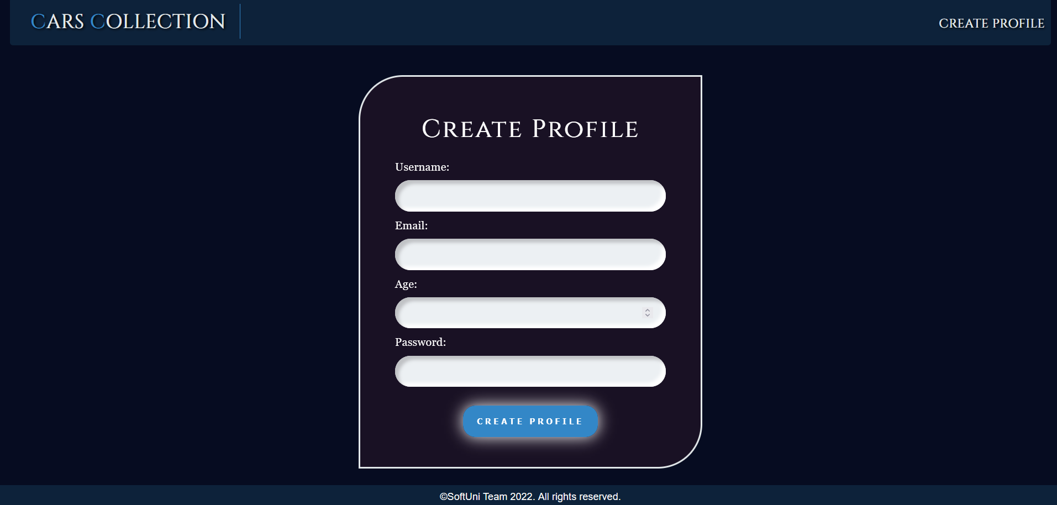

### Catalogue Page

**Template file**: **"catalogue.html"**

The **catalogue page shows all cars which have been created by the user.**

If the **user** **has a profile**, but there are **no cars created yet**, the page should have the following:

* A navigation bar, as shown below.
* A paragraph **"No cars yet"**

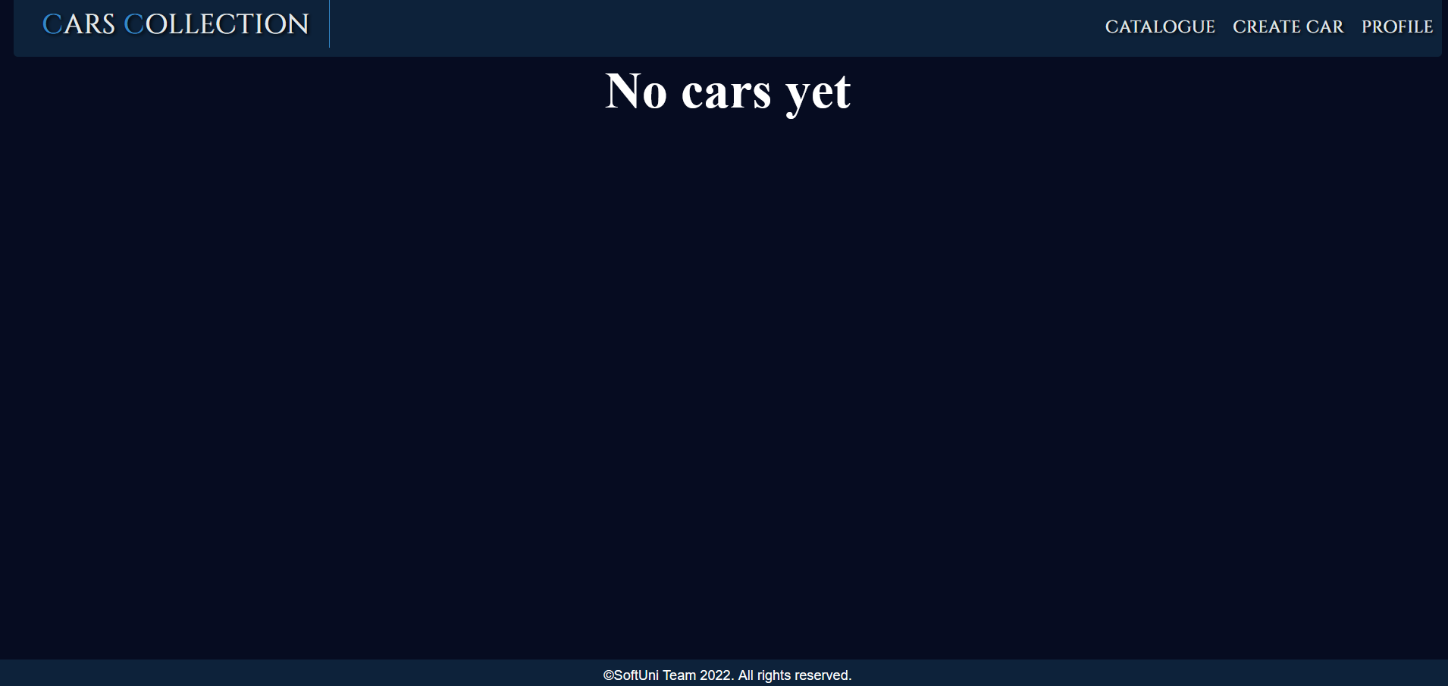

If the **user** **has a profile** and **cars,** the page should have the following:

* A navigation bar, as shown below.
* The total **number of cars**.
* A division for each car, showing:
* The car's **image**
* The car's **type**
* The car's **model**
* A **button** **"Details"** leading to the **details page** for the selected game

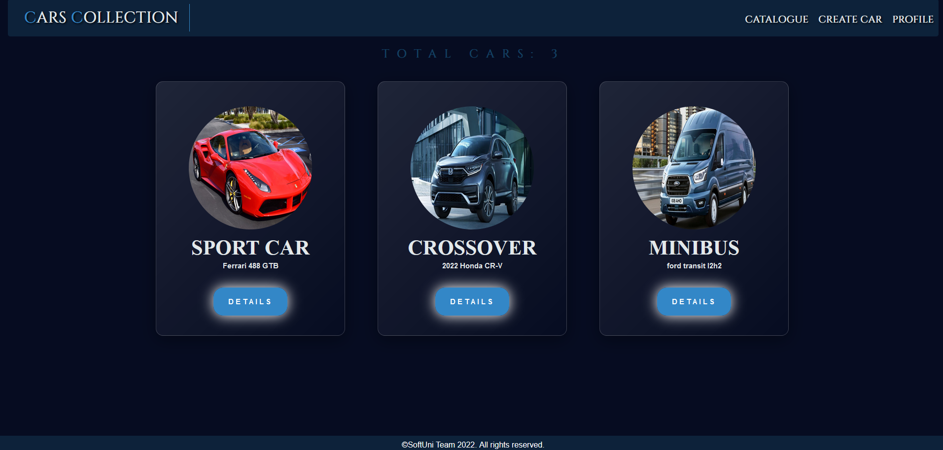

### Car Create Page

Template file: **"create-car.html"**

The page consists of:

* A **navigation bar,** as shown below.
* A **car** **creation form** consisting of:
* A **"Type:"** field
* A **"Model:"** field
* An **"Year:"** field
* An **"Image URL:"** field
* A **"Price:"** field
* A button **"Create Car"**
* When you **click** on it, **if** the car is **successfully created**, you should be redirected to the **catalogue page**.
* Otherwise, the form should show the **appropriate validation errors**.

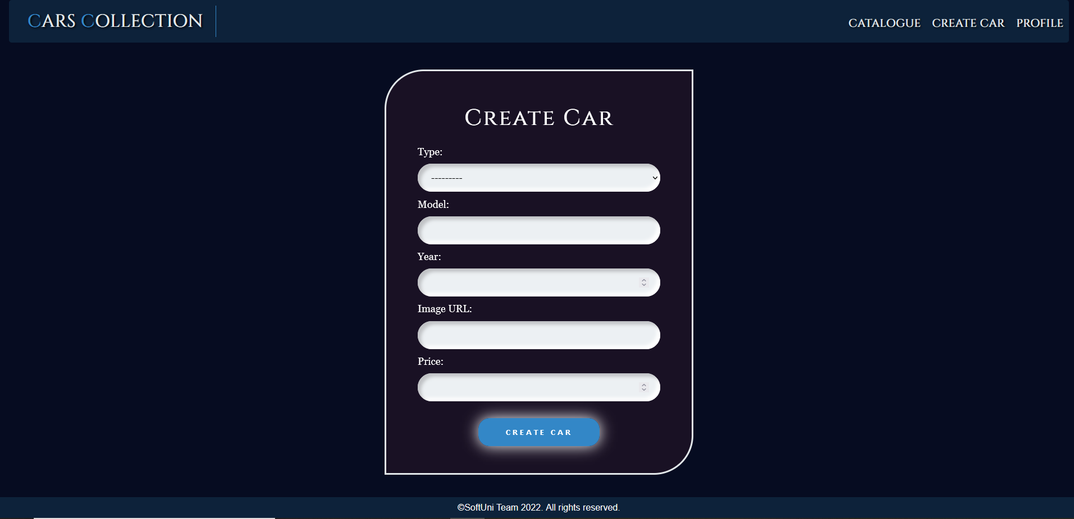

### Car Details Page

Template file: **"car-details.html"**

This page contains a car's information. It should have the following:

* The **car's image**
* The **car's type**
* The **car's model**
* The **car's year**
* The **car's price**, formatted to the **3rd decimal place**
* An **"Edit"** button that leads to the **edit car page**
* A **"Delete"** button that leads to the **delete car page**

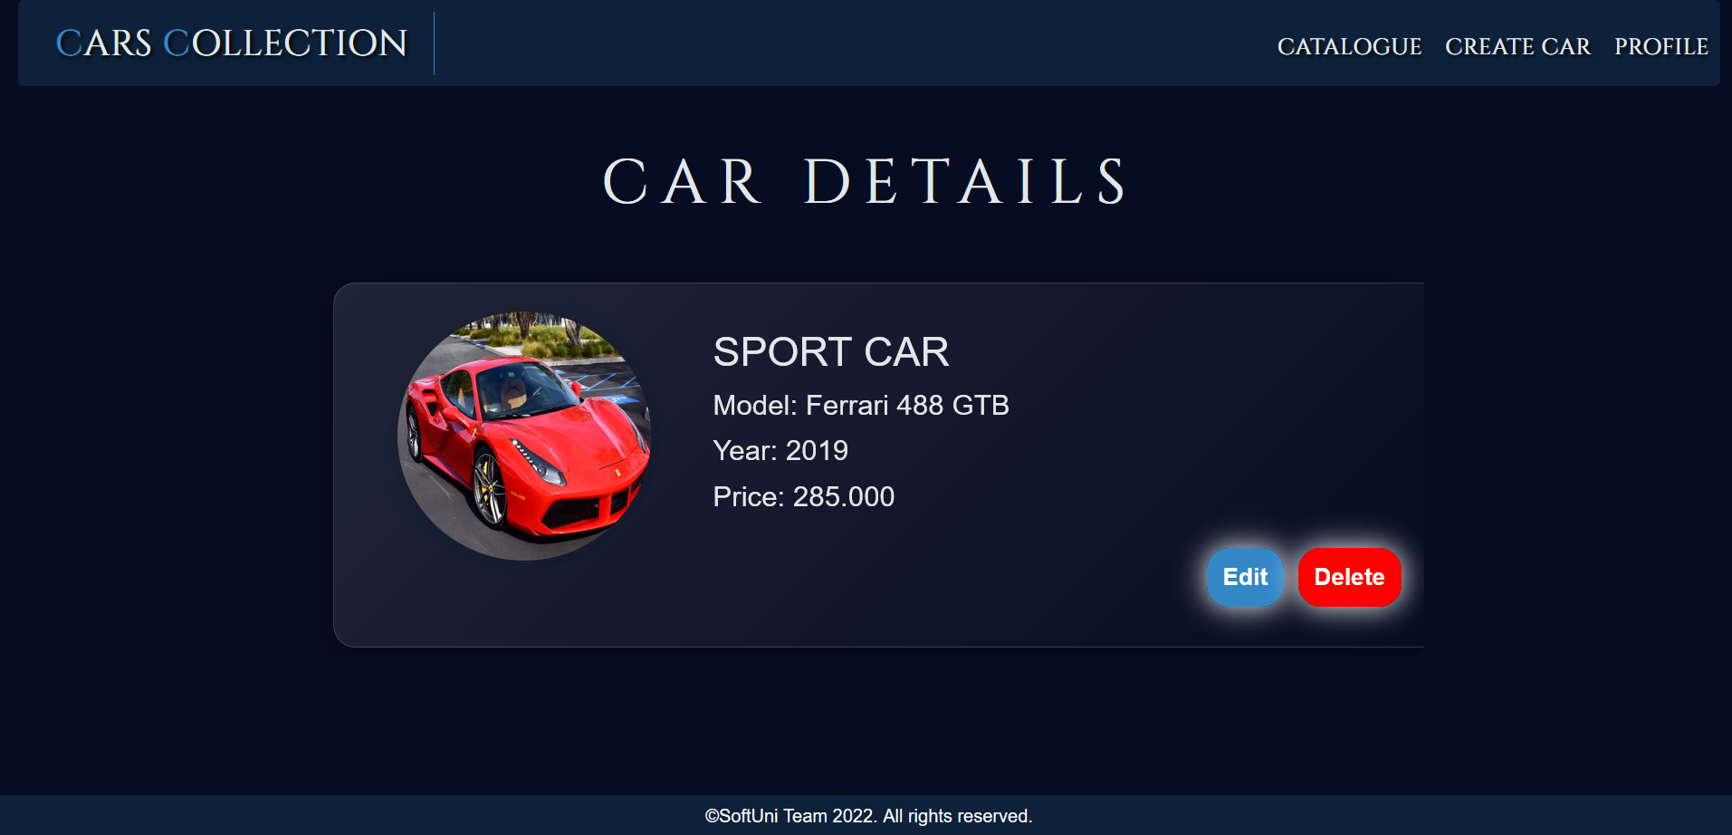

### Car Edit Page

Template file: **"edit-car.html"**

On the page, the form must be **filled** with the **information** of the **car** we want **to edit.**

When you click on the **"Edit Car"** button:

* **If** the car is **successfully edited**,you should be redirected to the **catalogue** **page**.
* **Otherwise**, the form should show the **appropriate validation errors**.

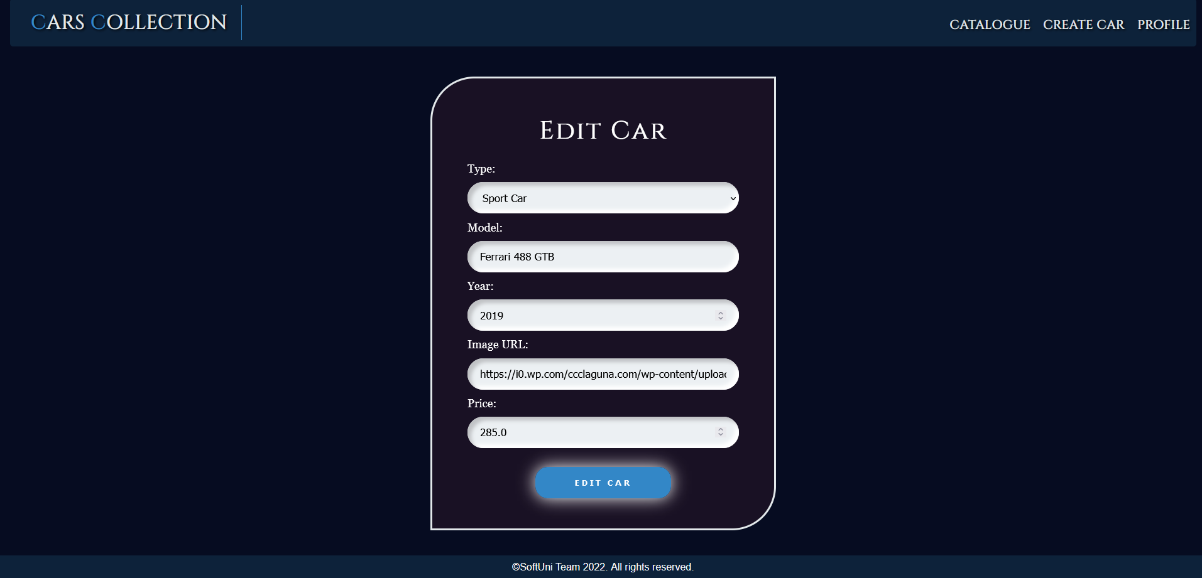

### Car Delete Page

Template file: **"delete-car.html"**

On the page, the form must be **filled** with the **car's infromation,** and **all the fields** should be **disabled.** When you click on the **"Delete Car"** button, the **car** is **deleted from the database**, and you should be redirected to the **catalogue page**.

The deleted car should be **no longer visible in the app**.

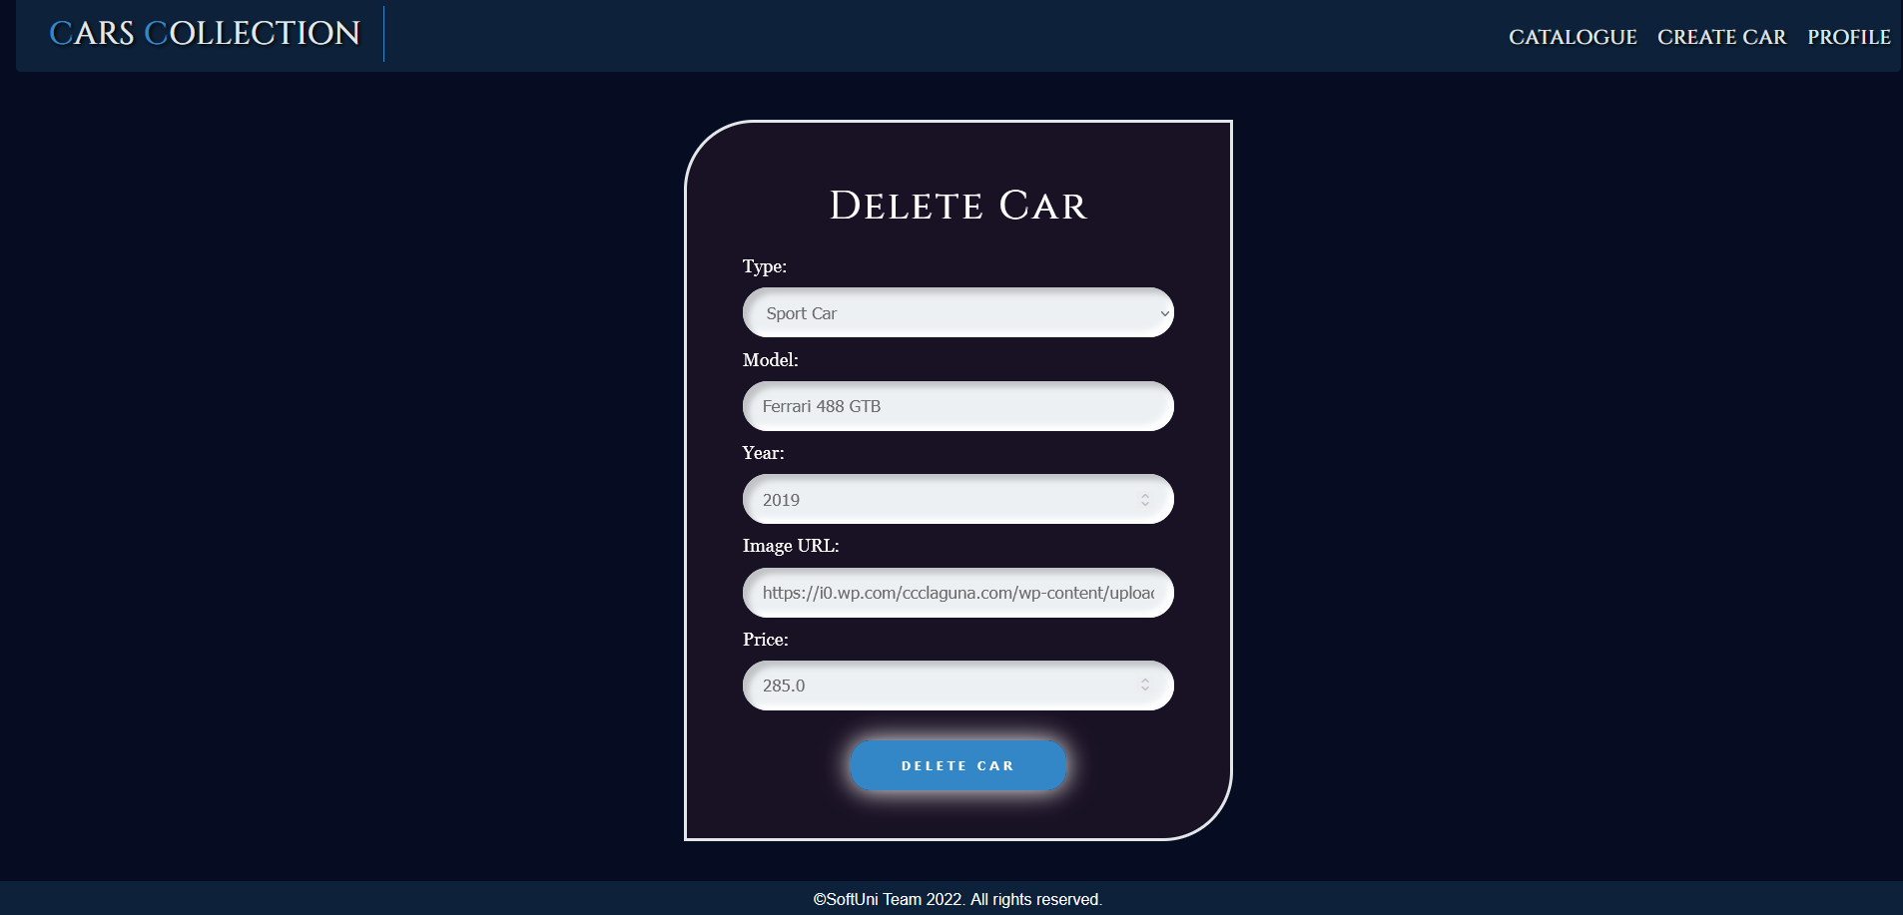

### Profile Details Page

Template file: **"profile-details.html"**

This page contains the **user's information**. It should have the following:

* A **profile** **picture**. If **no is given**, the page should show a **default profile picture** (in the static/image folder)
* A **name**:
* If **both names** are entered, show them separated by a **single** **space**
* If **only** the **first name** or **only** the **last name** is entered, show the **entered name only**
* Otherwise, ignore the line (do not show anything)
* The **username**
* The **email**
* The **age**
* The **total price of all cars**, formatted to the 3rd decimal place
* An **"Edit"** button that leads to the **profile edit page**
* A **"Delete"** button that leads to the **profile delete page**

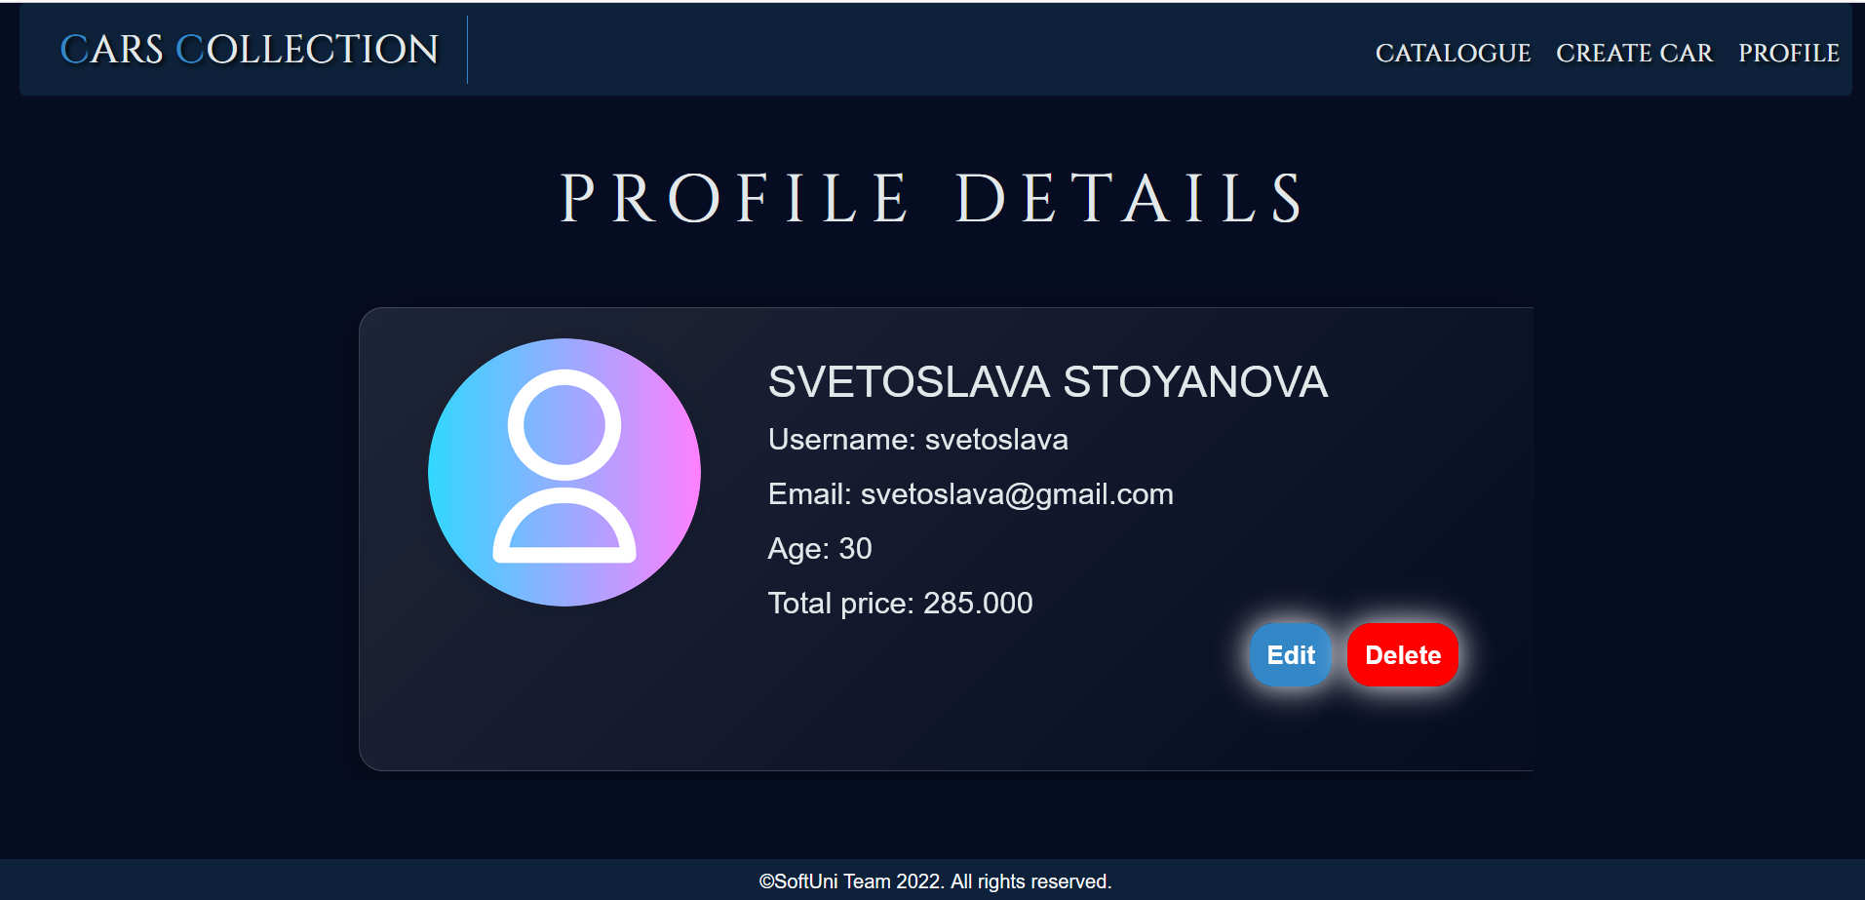

### Profile Edit Page

Template file: **"edit-profile.html"**

On the page, the form must be **filled** with the **information** of the **profile** we want **to edit. The password could be visible or hidden. The profile** **edition form** has **additional fields as shown below**:

* A **"First Name:"** field
* A **"Last Name:"** field
* A **"Profile Picture:"** field

When you click on the **"Edit Profile"** button:

* **If** the profile is **successfully edited**,you should be redirected to the **profile page**.
* **Otherwise**, the form should show the **appropriate validation errors**.

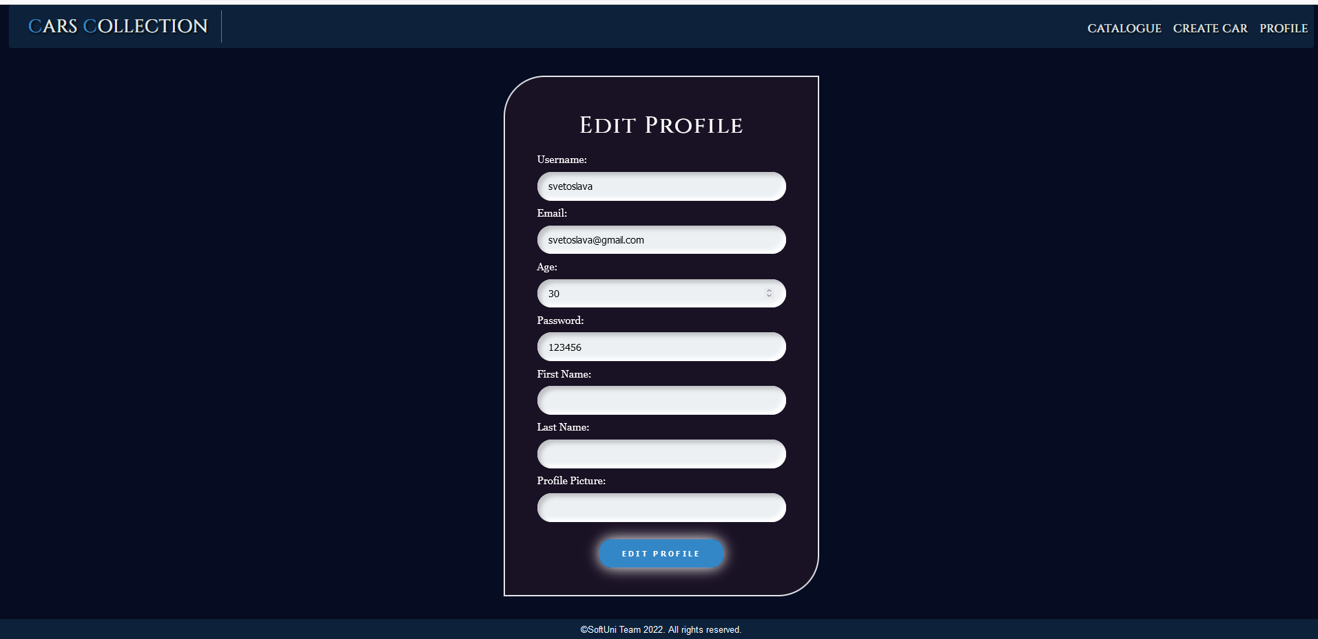

### Profile Delete Page

Template file: **"delete-profile.html"**

Deleting a profile should delete the profile info and **all of his cars.** After **deletion**, the user should be redirected to the **index page**.

